DATA SCIENCE WITH PYTHON
Supervised Learning Model Implementation
One-month-ahead jurisdiction COVID-19 death forecasting
━━━━━━━━━━━━━━━━━━━━━━━━━━━━━━━━━━━━━━━━━━━━━━━
WEEK | 4
DATE | 14 August 2026
DATASET | Provisional COVID-19 Deaths by Sex and Age

Student name | Mandal Sahil Naushad
Institution | YuvaIntern
Public-use aggregate mortality data • Reproducible Python workflow

Report map
The document follows the required submission structure. Major sections are separated visually and use Word heading styles for navigation.
- 1. Title Page
- 2. Introduction
- 3. Dataset Overview
- 4. Methodology
- 5. Python Code Sections
- 6. Results and Findings
- 7. Visualizations (described in text)
- 8. Challenges and How They Were Handled
- 9. Discussion
- 10. Conclusion
- 11. References

2. Introduction
This report frames the CDC data as a supervised regression problem: predict each jurisdiction's COVID-19 deaths one month ahead using only information available before the forecast month. The problem is useful for staffing and surveillance planning, but the exercise is also designed to expose where a conventional tree model fails when the pandemic regime changes.
The cleaned dataset was retained because it supplies monthly COVID-19, all-cause, and pneumonia counts for 52 non-overlapping jurisdictions from 2020 through August 2023. The key question is not whether a model can fit historical waves; it is whether it improves on the simple and operationally strong rule of using the previous month's count.
Bottom line. The gradient-boosted model is not deployment-ready. On the January–August 2023 test period it underperforms the previous-month baseline on MAE, RMSE, R², and WAPE. Reporting that failure is part of correct model evaluation, not a reason to hide the holdout result.

3. Dataset Overview
The 137,700-row source mixes monthly, yearly, and cumulative records. Modeling uses only By Month, All Sexes, All Ages rows for 52 jurisdictions; United States and New York City are excluded for the same independence reasons used in Week 3. Partial September 2023 is excluded.
Stage | Rows | Period | Purpose
Feature-ready panel | 2,069 | Apr 2020–Aug 2023 | Rows with three lags, rolling history, observed target, and lagged covariates.
Final training | 1,690 | Apr 2020–Dec 2022 | Fit model before the holdout period.
Final test | 379 | Jan–Aug 2023 | Strict future evaluation; suppressed targets are excluded.
CV fold 1 | 760 train / 310 validation | Validate Jul–Dec 2021 | Expansion-window check during a high-wave regime.
CV fold 2 | 1,070 / 311 | Validate Jan–Jun 2022 | Check transition from winter peak.
CV fold 3 | 1,381 / 309 | Validate Jul–Dec 2022 | Check lower, smoother late-2022 regime.
Table 1. Chronological split design.
For lag predictors only, a suppressed count is represented by the midpoint 5 of the known interval 1–9. A row with a suppressed target is never scored as though 5 were observed; it is removed from training/evaluation. This separates a bounded predictor approximation from ground-truth fabrication.

4. Methodology
The workflow defines the supervised problem, preprocesses and engineers leak-free features, trains a selected model, uses expanding-time validation, and evaluates several metrics plus failure cases.

Step 1 — Define the target and forecast horizon
The target is the current row's monthly COVID-19 death count, while every count predictor is shifted by at least one month within jurisdiction. The task is therefore a one-step-ahead forecast, not a contemporaneous explanation. September 2023 is removed because it covers only 23 days.

Step 2 — Engineer features without future information
Features are COVID-19 lags 1–3, the previous three-month mean, prior-month total deaths, prior-month pneumonia deaths, sine and cosine of month, a linear time index, and one-hot jurisdiction identity. Lagged respiratory and all-cause measures capture recent scale; cyclical terms represent season; one-hot identity allows persistent level differences without imposing an artificial state order.

Step 3 — Use chronological validation
Three expanding-window folds respect calendar order. Random cross-validation was rejected because adjacent months and pandemic waves are autocorrelated; random splitting would let future-regime examples inform earlier predictions. The latest complete months, January–August 2023, remain untouched for final testing.

Step 4 — Choose the model and transformations
I used HistGradientBoostingRegressor with shallow leaf structure, learning rate 0.05, 350 boosting iterations, minimum 12 samples per leaf, and L2 regularization. Gradient boosting captures nonlinear interactions among lags, season, and jurisdiction. The target is log1p-transformed to reduce domination by California/Texas and peak waves, then transformed back for count-scale metrics.

Step 5 — Benchmark against a hard-to-beat baseline
The baseline predicts that next month equals the previous month. In a smooth low-burden period this rule can be excellent. A useful model must outperform it, not merely show positive R². The same target rows are used for model and baseline metrics.

Step 6 — Evaluate trade-offs and inspect failures
MAE describes the typical absolute miss in deaths, RMSE penalizes large misses more strongly, R² measures variance explained relative to a mean predictor, and WAPE expresses total absolute error relative to total observed deaths. Error tables identify months and jurisdictions where summary metrics hide operationally serious misses.

5. Python Code Sections

Code 1 — Imports, cleaned panel, and non-overlapping jurisdictions
```python
import numpy as np
import pandas as pd
from sklearn.compose import ColumnTransformer
from sklearn.ensemble import HistGradientBoostingRegressor
from sklearn.metrics import mean_absolute_error, mean_squared_error, r2_score
from sklearn.pipeline import Pipeline
from sklearn.preprocessing import OneHotEncoder, StandardScaler
df = pd.read_csv("cleaned_covid_deaths.csv",
parse_dates=["data_as_of", "start_date", "end_date"])
jurisdictions = sorted(set(df["state"]) - {"United States", "New York City"})
panel = df.query(
"group == 'By Month' and sex == 'All Sexes' and age_group == 'All Ages'"
).loc[lambda x: x["state"].isin(jurisdictions) & ~x["is_partial_period"]]
panel = panel.sort_values(["state", "start_date"])
```
Code explanation and output interpretation
- The model uses one monthly all-age, all-sex series per non-overlapping jurisdiction.
- Sorting within state is required before lag construction; otherwise shift would connect unrelated jurisdictions.
- Removing partial periods prevents a 23-day September target from being learned as a full-month decline.

Code 2 — Create lagged and seasonal features
```python
for col in ["covid_deaths", "total_deaths", "pneumonia_deaths"]:
panel[f"{col}_for_lag"] = panel[col].fillna(5.0)
g = panel.groupby("state", observed=True)
panel["lag1_covid"] = g["covid_deaths_for_lag"].shift(1)
panel["lag2_covid"] = g["covid_deaths_for_lag"].shift(2)
panel["lag3_covid"] = g["covid_deaths_for_lag"].shift(3)
panel["rolling3_covid"] = g["covid_deaths_for_lag"].transform(
lambda s: s.shift(1).rolling(3).mean()
)
panel["lag1_total"] = g["total_deaths_for_lag"].shift(1)
panel["lag1_pneumonia"] = g["pneumonia_deaths_for_lag"].shift(1)
panel["month_sin"] = np.sin(2 * np.pi * panel["month"] / 12)
panel["month_cos"] = np.cos(2 * np.pi * panel["month"] / 12)
panel["time_index"] = (panel["start_date"].dt.year - 2020) * 12 + panel["month"] - 1
```
Code explanation and output interpretation
- The midpoint 5 is used only when a lagged predictor is interval-suppressed; observed targets remain required for scoring.
- All rolling calculations shift first, so the current target cannot enter its own predictors.
- Sine and cosine encode December–January adjacency, unlike a raw month integer that places them far apart.

Code 3 — Define preprocessing and the gradient-boosted regressor
```python
num_features = [
"lag1_covid", "lag2_covid", "lag3_covid", "rolling3_covid",
"lag1_total", "lag1_pneumonia", "month_sin", "month_cos", "time_index"
]
cat_features = ["state"]
model_data = panel.dropna(subset=num_features + ["covid_deaths"]).copy()
preprocess = ColumnTransformer([
("numeric", StandardScaler(), num_features),
("state", OneHotEncoder(handle_unknown="ignore", sparse_output=False), cat_features),
])
model = HistGradientBoostingRegressor(
learning_rate=0.05, max_iter=350, max_leaf_nodes=15,
min_samples_leaf=12, l2_regularization=1.0, random_state=42,
)
pipeline = Pipeline([("preprocess", preprocess), ("model", model)])
```
Code explanation and output interpretation
- One-hot encoding represents jurisdiction identity without treating state names as an ordered numeric variable.
- Regularization and minimum leaf size limit overly specific rules in a panel of only 2,069 usable observations.
- After encoding, the training design contains 61 features: nine numeric predictors and 52 jurisdiction indicators.

Code 4 — Run expanding-window validation
```python
folds = [
("2021 H2", "2021-07-01", "2021-12-01"),
("2022 H1", "2022-01-01", "2022-06-01"),
("2022 H2", "2022-07-01", "2022-12-01"),
]
for label, start, end in folds:
train = model_data[model_data["start_date"] < start]
valid = model_data[model_data["start_date"].between(start, end)]
pipeline.fit(train[num_features + cat_features], np.log1p(train["covid_deaths"]))
pred = np.clip(np.expm1(pipeline.predict(valid[num_features + cat_features])), 0, None)
baseline = valid["lag1_covid"].to_numpy()
print(label, mean_absolute_error(valid["covid_deaths"], pred),
mean_absolute_error(valid["covid_deaths"], baseline))
```
Code explanation and output interpretation
- Each fold trains only on dates earlier than its validation block, reproducing how the model would have been used at the time.
- The model beats the baseline in 2021 H2 and 2022 H1 but loses badly in 2022 H2, exposing regime-dependent performance.
- That instability is visible before the final 2023 test and argues against selecting a model from one favorable split.

Code 5 — Fit through 2022 and evaluate January–August 2023
```python
train = model_data[model_data["start_date"] < "2023-01-01"]
test = model_data[model_data["start_date"].between("2023-01-01", "2023-08-01")]
X_cols = num_features + cat_features
pipeline.fit(train[X_cols], np.log1p(train["covid_deaths"]))
pred = np.clip(np.expm1(pipeline.predict(test[X_cols])), 0, None)
actual = test["covid_deaths"].to_numpy()
metrics = {
"MAE": mean_absolute_error(actual, pred),
"RMSE": mean_squared_error(actual, pred) ** 0.5,
"R2": r2_score(actual, pred),
"WAPE_pct": 100 * np.abs(actual - pred).sum() / actual.sum(),
}
print(metrics)
```
Code explanation and output interpretation
- The final fit uses all observed rows through December 2022 and never sees 2023 targets during training.
- Test results are MAE 69.259, RMSE 116.878, R² 0.490, and WAPE 54.239% on 379 observed jurisdiction-months.
- These values must be compared with the previous-month baseline rather than interpreted in isolation.

Code 6 — Compare the baseline and isolate failure cases
```python
baseline_pred = test["lag1_covid"].to_numpy()
baseline_metrics = {
"MAE": mean_absolute_error(actual, baseline_pred),
"RMSE": mean_squared_error(actual, baseline_pred) ** 0.5,
"R2": r2_score(actual, baseline_pred),
"WAPE_pct": 100 * np.abs(actual - baseline_pred).sum() / actual.sum(),
}
errors = test[["state", "start_date", "covid_deaths"]].copy()
errors["prediction"] = pred
errors["absolute_error"] = np.abs(errors["covid_deaths"] - errors["prediction"])
print(baseline_metrics)
print(errors.nlargest(10, "absolute_error"))
```
Code explanation and output interpretation
- The baseline reaches MAE 48.892, RMSE 84.661, R² 0.732, and WAPE 38.289%, outperforming the model on every test metric.
- The gradient model's MAE is 41.66% worse than the baseline, so positive R² is not sufficient evidence for deployment.
- California January 2023 is the largest model miss: actual 1,327 versus predicted 2,550.8, an absolute error of 1,223.8 deaths.

6. Results and Findings
Model | MAE | RMSE | R² | WAPE
Gradient-boosted model | 69.259 | 116.878 | 0.490 | 54.239%
Previous-month baseline | 48.892 | 84.661 | 0.732 | 38.289%
Table 2. Final January–August 2023 holdout performance; lower MAE/RMSE/WAPE and higher R² are better.
Validation block | Model MAE | Baseline MAE | Winner | Interpretation
2021 H2 | 359.550 | 395.694 | Model | Nonlinear lag structure helps during volatile waves.
2022 H1 | 192.253 | 386.325 | Model | Model captures part of the winter-peak decline.
2022 H2 | 118.633 | 58.696 | Baseline | Persistence dominates in a smoother low-burden regime.
2023 Jan–Aug test | 69.259 | 48.892 | Baseline | Late-period dynamics remain closer to persistence.
Table 3. Expanding-window evidence shows that relative performance changes by pandemic regime.
MAE answers the operational question 'how many deaths off is the typical jurisdiction-month forecast?' RMSE is much larger than MAE for both methods, confirming a small number of large-state errors. R² remains positive for the gradient model, but the stronger baseline explains substantially more variance. WAPE shows the model's total absolute error equals 54.239% of total observed deaths in the test rows, which is too high for planning without wide uncertainty bands.
The failure is systematic rather than random noise. The model overpredicts several large jurisdictions during the 2023 decline, including California, Florida, and Texas. Tree boosting interpolates historical lag patterns but does not extrapolate a continuing structural decline well. The log target reduces peak dominance, yet the learned mapping still reflects the high-wave training regimes.

7. Visualizations (described in text)
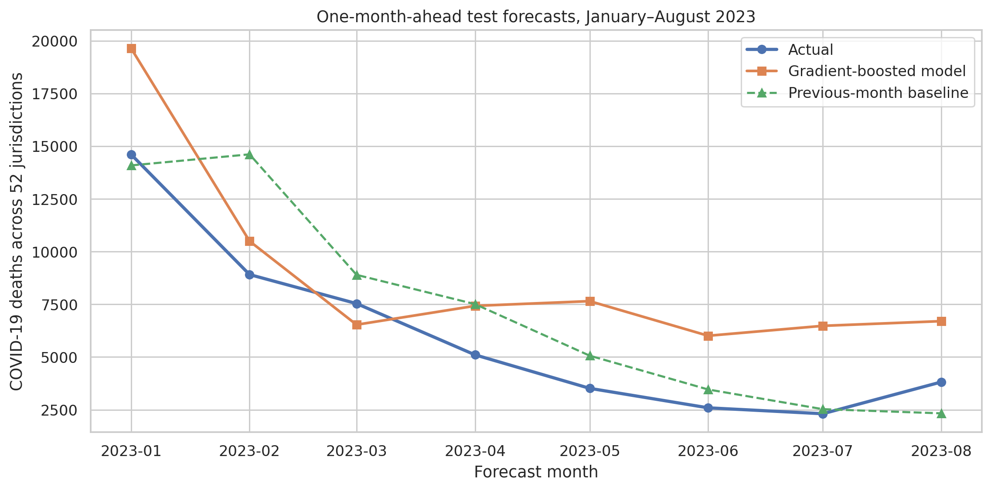
Figure 1. Aggregate actual, gradient-boosted, and previous-month forecasts over the final eight-month test period.
Technical reading: lines sum predictions across available scored jurisdictions for each test month. Analytical reading: the boosted model remains too high through much of the decline, whereas the previous-month line follows persistence more closely. Aggregation can hide state errors, so this view is paired with point-level diagnostics.
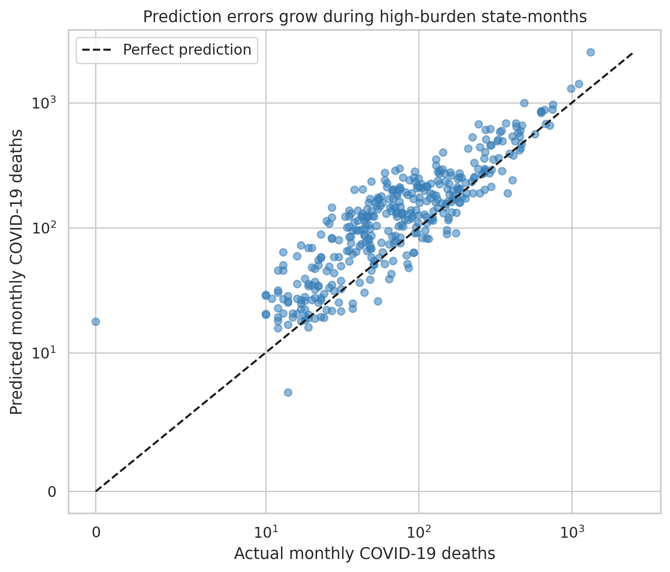
Figure 2. Actual versus predicted jurisdiction-month counts on symmetric log-scaled axes; the dashed line is perfect prediction.
Technical reading: points above the diagonal are overpredictions and points below are underpredictions; the log-like scale shows both small and large states. Analytical reading: dispersion expands at high counts, confirming heteroscedasticity and explaining why RMSE is especially sensitive to large-state misses.
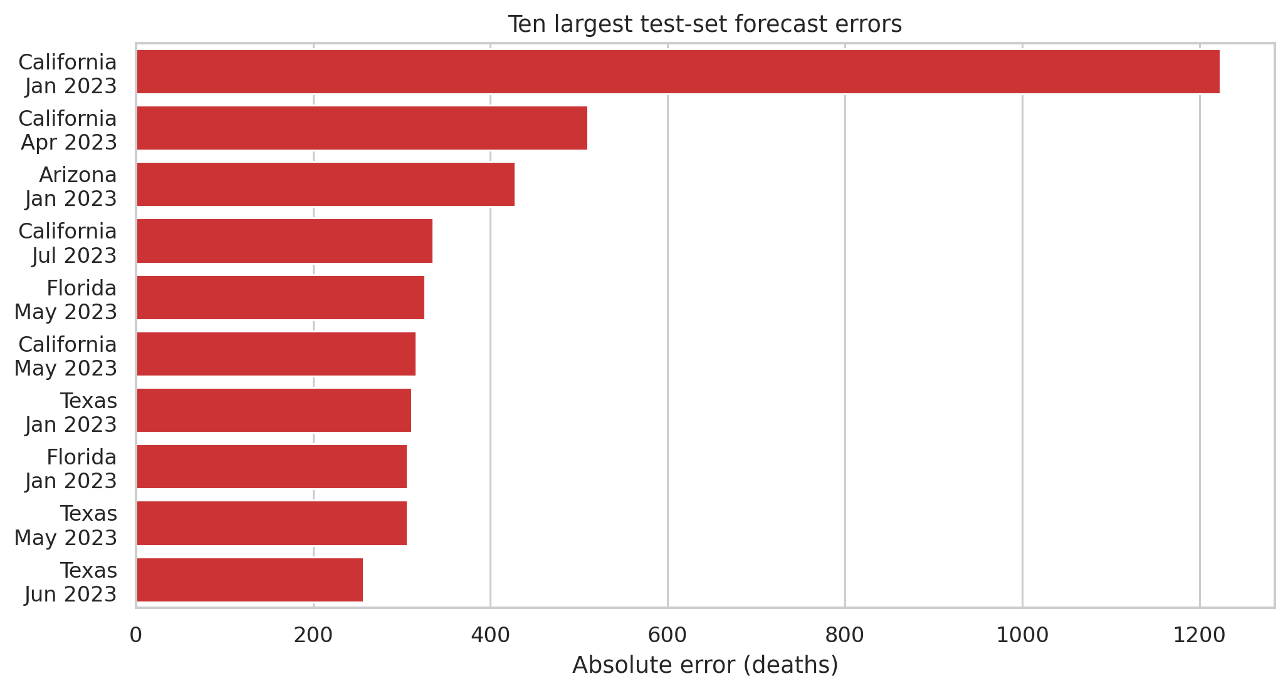
Figure 3. Ten largest absolute errors in the January–August 2023 holdout.
Technical reading: bars rank state-months by absolute error in deaths. Analytical reading: California, Texas, Florida, and Arizona recur among the worst misses. A national-average score would understate the operational risk concentrated in populous jurisdictions.

8. Challenges and How They Were Handled
- Temporal leakage was the largest modeling risk. I used shifted features, expanding validation, and a future holdout instead of random splitting.
- Suppressed counts are interval-censored. Midpoint 5 is used only for lag predictors; suppressed target rows are not evaluated as exact observations.
- Jurisdictions differ sharply in scale. The target uses log1p, numeric features are standardized, and evaluation returns to the original count scale.
- The final month is incomplete. September 2023 is excluded through the Week 1 partial-period flag.
- A positive model R² could look acceptable without context. A previous-month baseline and four metrics reveal that the model is inferior in 2023.
- Performance changes by pandemic regime. Multiple chronological folds expose the reversal between early 2022 and late 2022 rather than averaging it away.

9. Discussion
The practical lesson is that model complexity must earn its place. The gradient model captures volatile transitions in two validation blocks, but late-2022 and 2023 behavior is closer to persistence. If deployed, its overprediction in large states could over-allocate scarce staff or supplies; underprediction during a new wave could be worse. A point forecast without prediction intervals is not enough for mortality planning.
The holdout also explains metric trade-offs. MAE is straightforward for routine planning, RMSE emphasizes rare large misses, R² supports comparison of explained variation, and WAPE is useful when volumes differ. None should be reported alone. MAPE was not used because small or suppressed targets make percentage errors unstable or undefined.
Limitations include a small time span, aggregate data, changing variants and reporting practices, missing predictors such as vaccination and hospital admissions, and a frozen source. HistGradientBoosting cannot extrapolate trends beyond combinations seen during training. The one-hot state effects are descriptive and may become stale if geography-specific dynamics shift.
The next improvement should retain the strong lag-1 forecast as an explicit skip path and train a model only to predict the correction. That reframes learning around month-to-month change, creates a safe zero-correction starting point, and is tested in Week 5 with a small regularized neural network.

10. Conclusion
A leak-free gradient-boosted regression pipeline was trained on 1,690 jurisdiction-months and tested on 379 future rows. Although it achieved R² 0.490, its MAE of 69.259 and WAPE of 54.239% were worse than the previous-month baseline's MAE 48.892 and WAPE 38.289%. The model is therefore rejected for deployment in its current form.
Week 5 will use the same chronological split and features but redesign the target as a log-scale correction to the previous month. The goal is not to add depth for its own sake; it is to preserve baseline behavior unless the network finds evidence for a better adjustment.

11. References
- Centers for Disease Control and Prevention, National Center for Health Statistics. Provisional COVID-19 Deaths by Sex and Age. Dataset page: https://data.cdc.gov/National-Center-for-Health-Statistics/Provisional-COVID-19-Deaths-by-Sex-and-Age/9bhg-hcku
- CDC data download used for source verification: https://data.cdc.gov/api/views/9bhghcku/rows.csv?accessType=DOWNLOAD
- CDC WONDER provisional mortality access noted by the publisher as the successor source: https://wonder.cdc.gov/mcd-icd10-provisional.html
- McKinney, W. pandas: Python Data Analysis Library. https://pandas.pydata.org/
- Harris, C. R. et al. (2020). Array programming with NumPy. Nature, 585, 357–362. https://numpy.org/
- Waskom, M. L. (2021). seaborn: statistical data visualization. Journal of Open Source Software, 6(60), 3021. https://seaborn.pydata.org/
- Pedregosa, F. et al. (2011). Scikit-learn: Machine Learning in Python. Journal of Machine Learning Research, 12, 2825–2830. https://scikit-learn.org/
- Hunter, J. D. (2007). Matplotlib: A 2D Graphics Environment. Computing in Science & Engineering, 9(3), 90–95. https://matplotlib.org/

